**Testing**

Introduction

Testing is the activity performed to make sure that weather actual result match the projected result and to make sure that software is defect free.

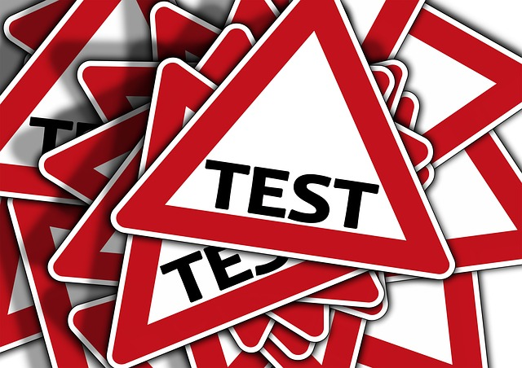

Important of performing testing are:

* Testing saves money and time as if the bug are tested and fixed in initial stage it cost less to fix them.
* It helps to improve the quality of the product.
* It help to identify the problems and threats and remove earlier.
* It brings best user experience possible.

Types of testing’s:

* Black box testing
* White box testing
* Unit testing
* Integration testing
* Beta testing

Among all the testing listed above, I have chosen only two type of testing and they are

* Black box testing
* Unit testing

1. **Black box testing**

Black box testing is the testing procedure that only focuses on giving the input and generating the excepted results and it ignores the internal code implementation of the system.

By choosing black box testing, we can test the project by only focusing on inputs and outputs not knowing the internal code implementation of the system.

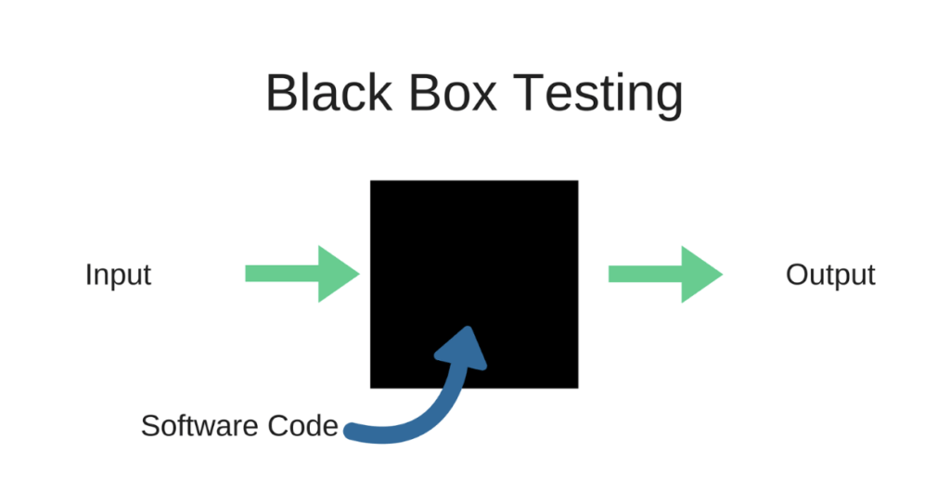

**Test cases**

1. **Test Name: Registration testing**

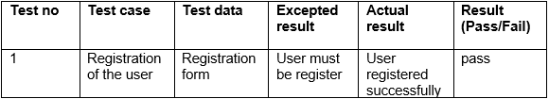

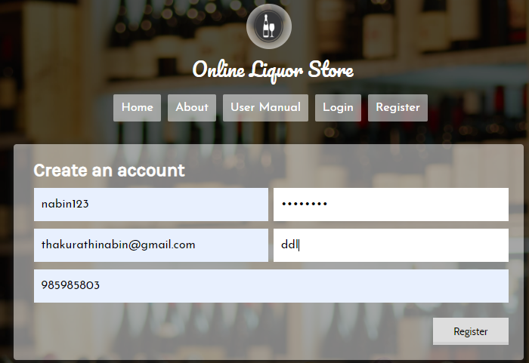

Fig 1: user registration

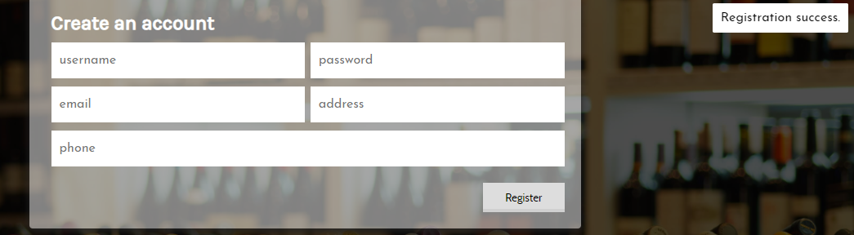

Fig 2: user registration successful.

1. **Test Name: Login test**

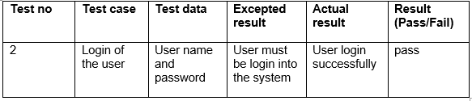

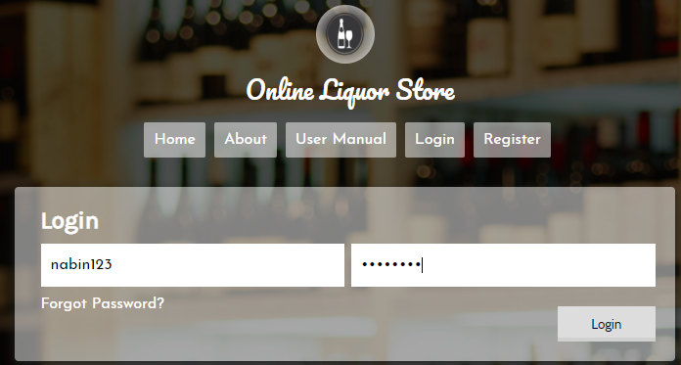

Fig 3: user login form

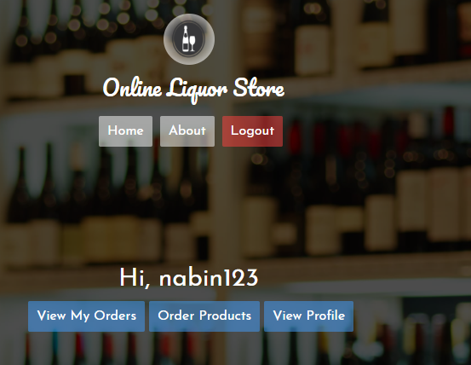

Fig 4: user login successful.

1. **Test Name : forget password**

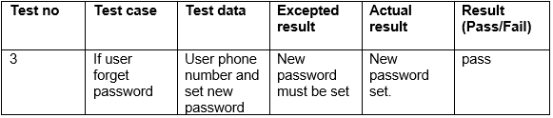

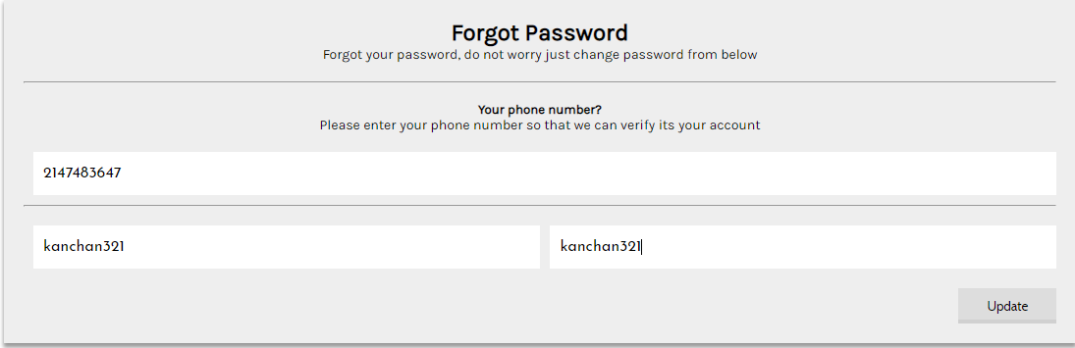

Fig 5: set new password

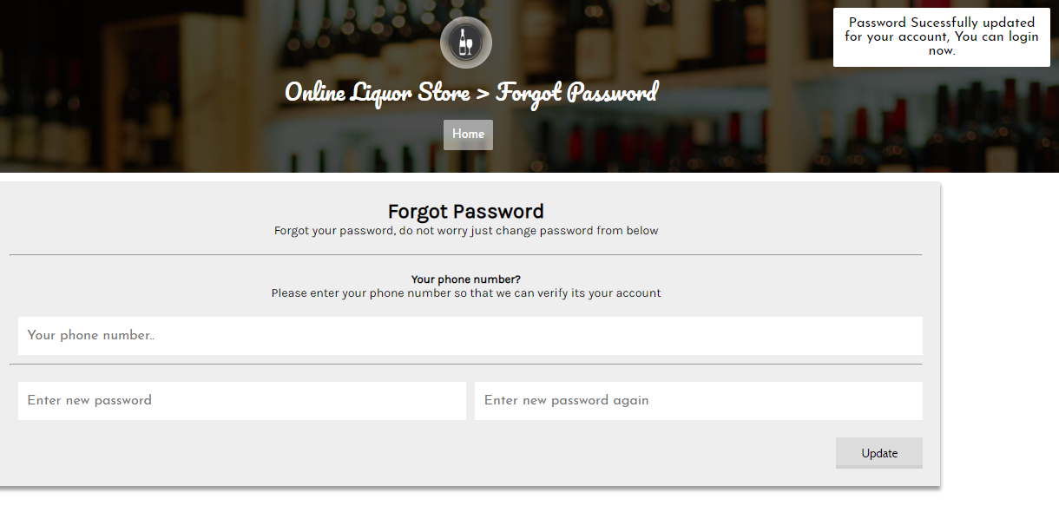

Fig 6: new password updated.

1. **Test Name : Admin Login**

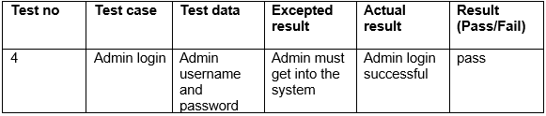

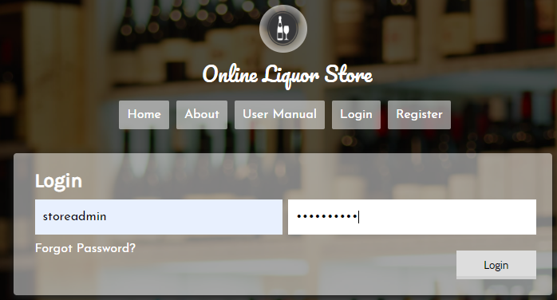

Fig 7: admin login

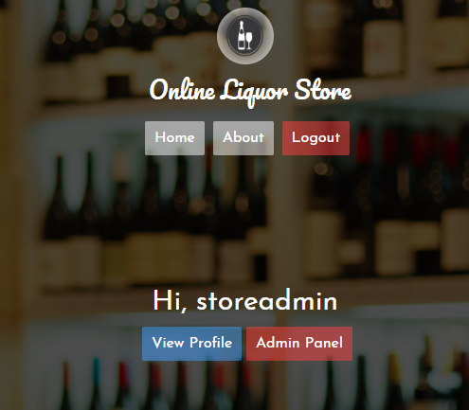

Fig 8: admin login successful.

1. **Test Name : User profile edit**

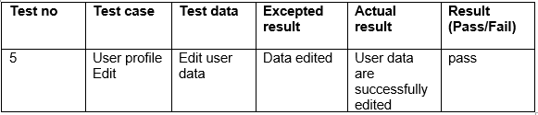

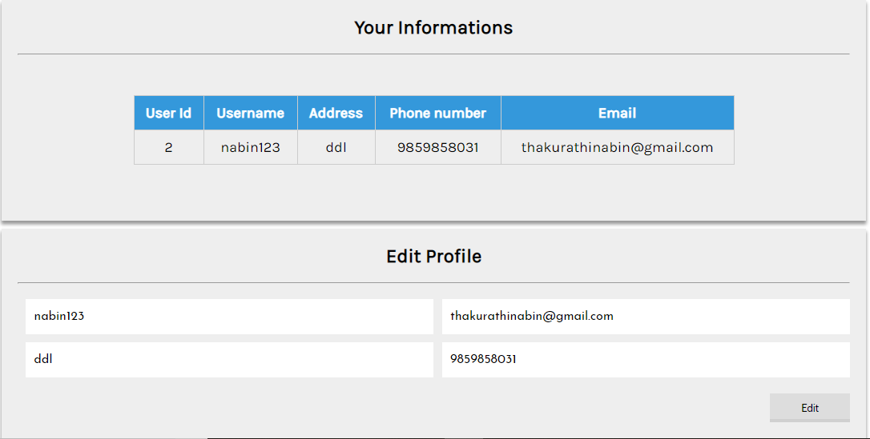

Fig 9: user details.

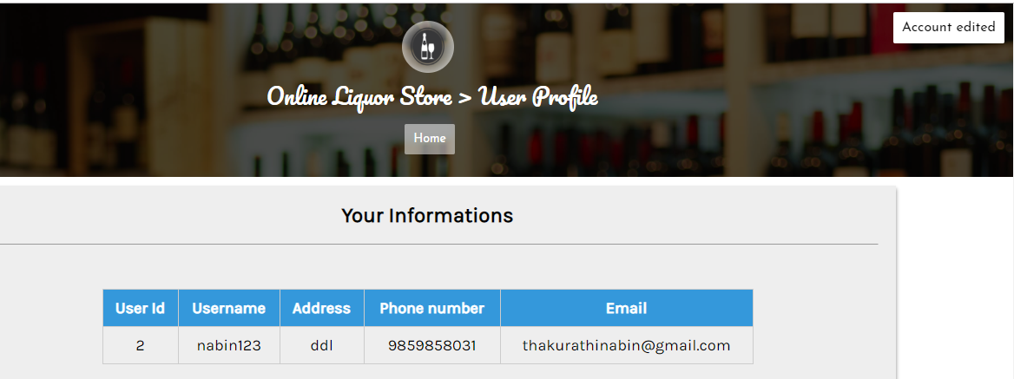

Fig 10: user account edited.

1. **Test Name : order products**

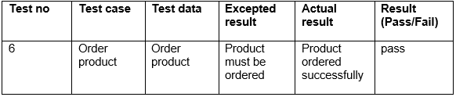

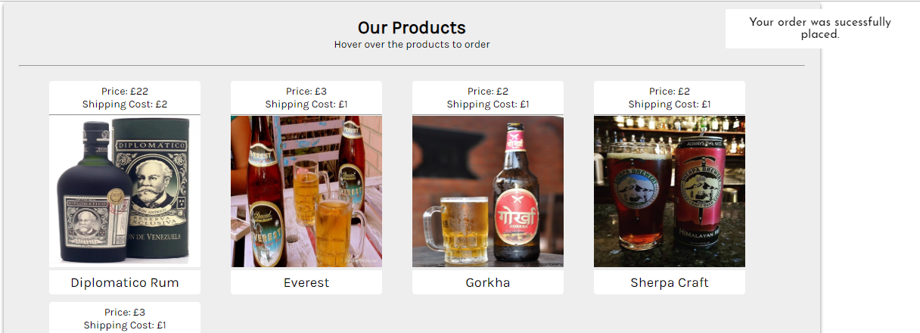

Fig 11: product ordered successfully.

1. **Test Name : View order**

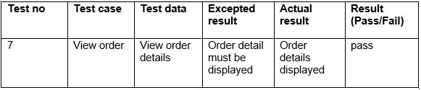

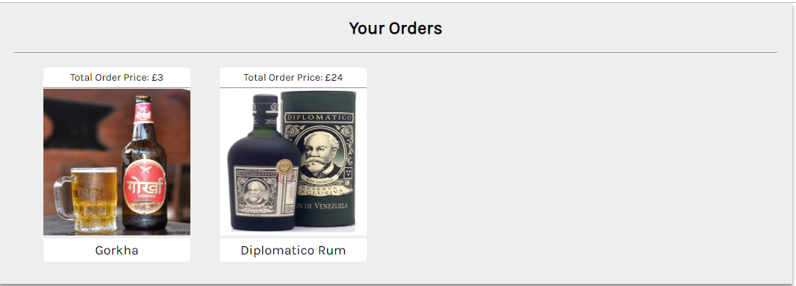

Fig 12: view customer orders.

1. **Test Name : Add product by admin**

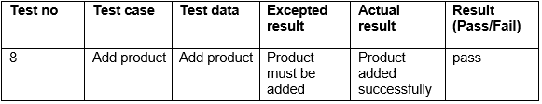

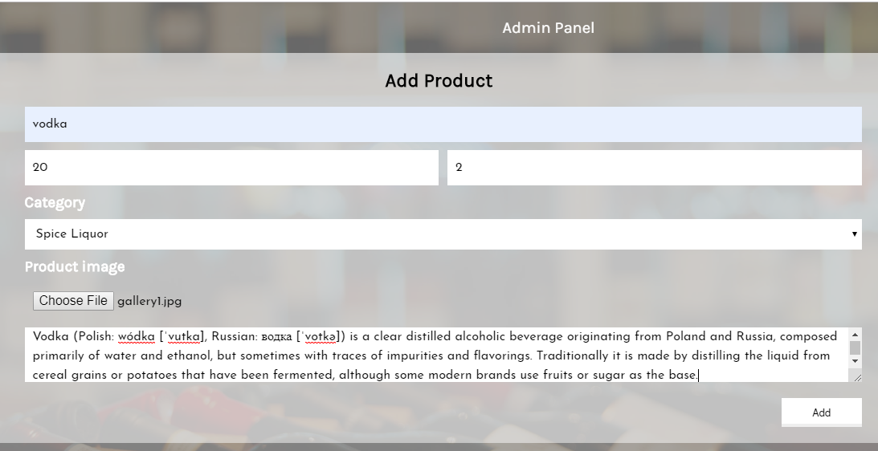

Fig 13: adding product by admin

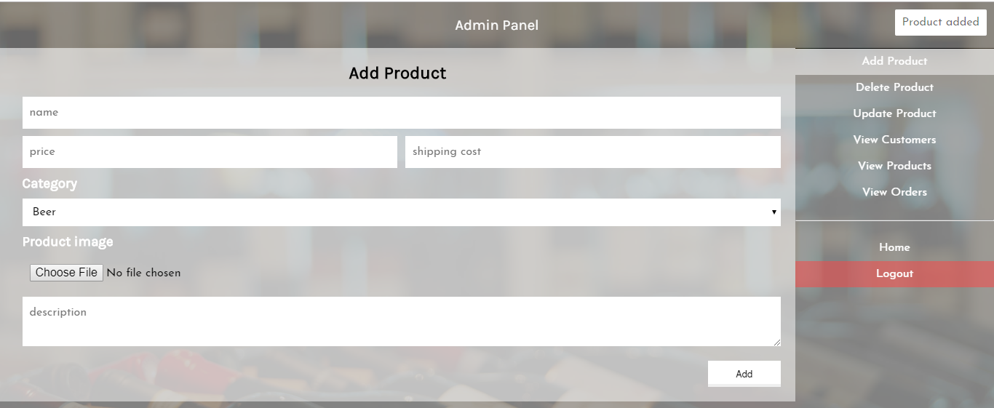

Fig 14: product added successfully.

1. **Test Name : view product details by admin**

As admin need product id to delete the product so he need to view product details before delete.

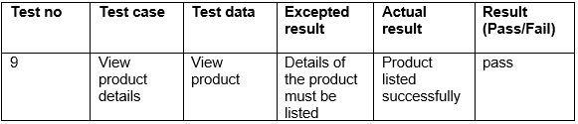

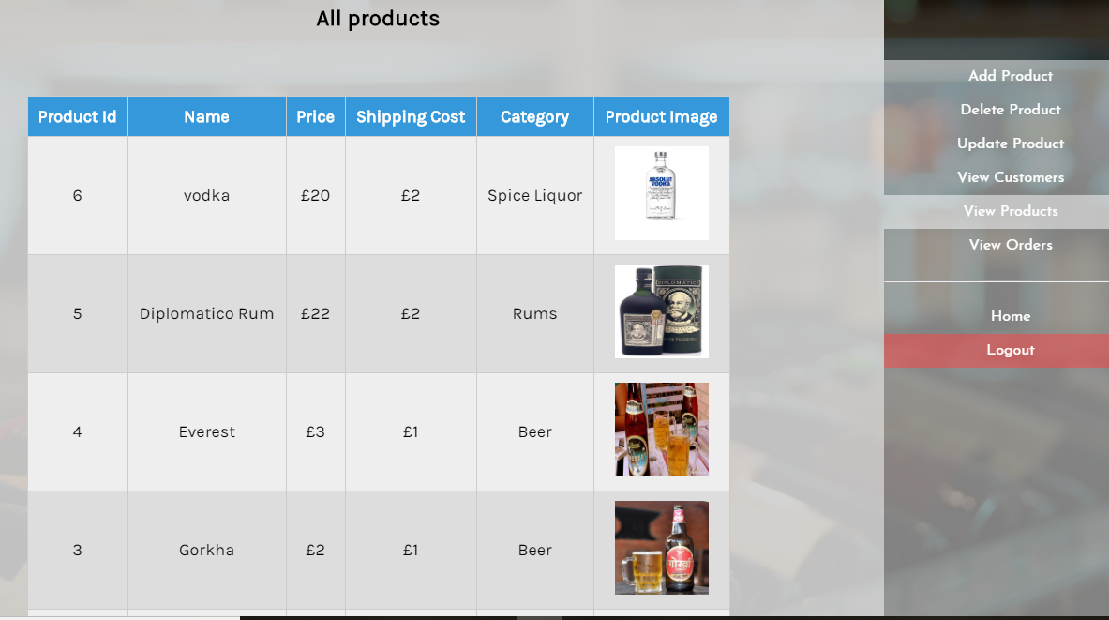

Fig 15: product details are displayed successfully.

1. **Test Name : Delete product**

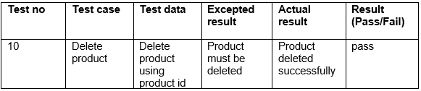

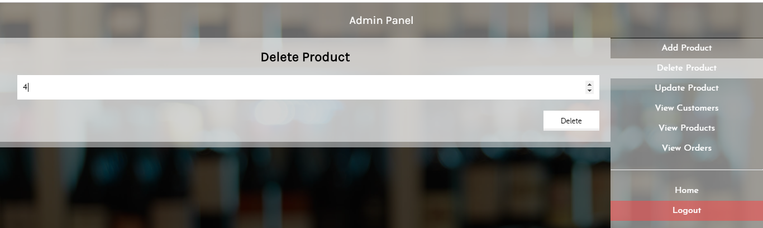

Fig 16: deleting product using product id.

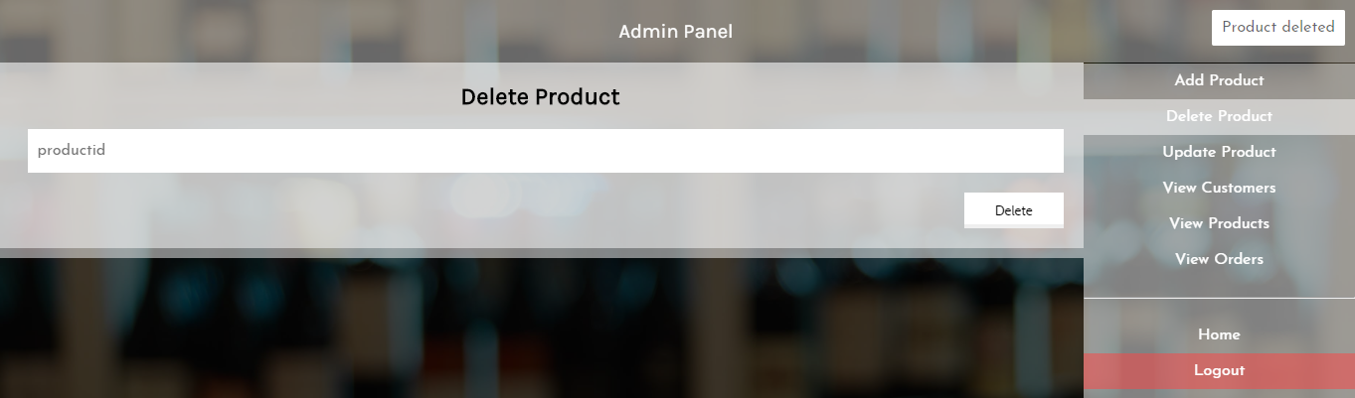

Fig 17: product deleted.

1. **Test Name : update product**

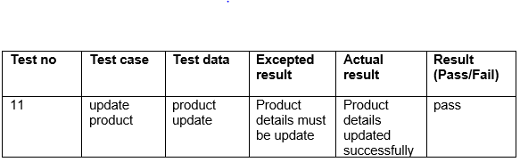

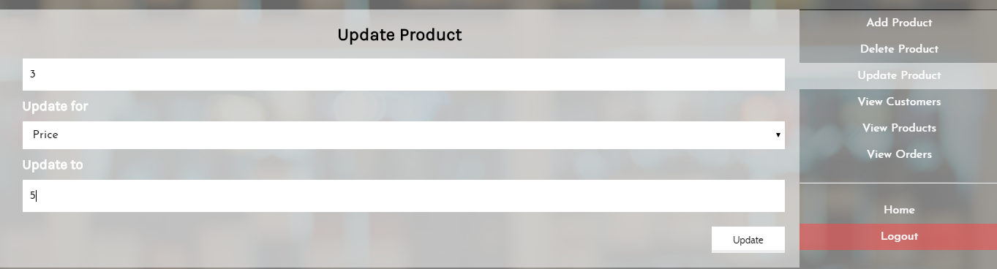

Fig 18: updating product by using product id.

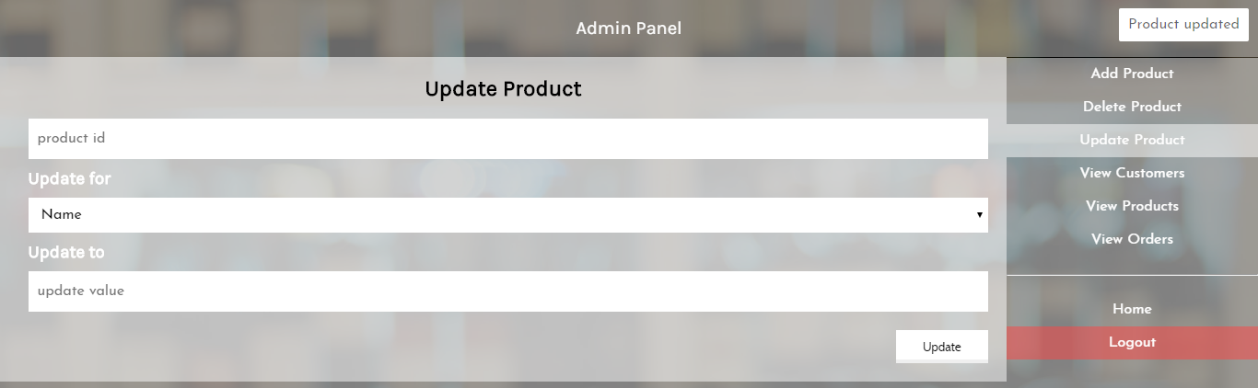

Fig 19: product updated.

1. **Test Name : customer details view by admin.**

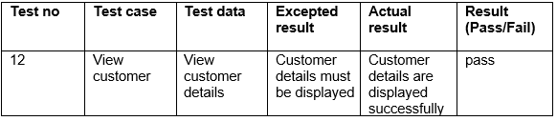

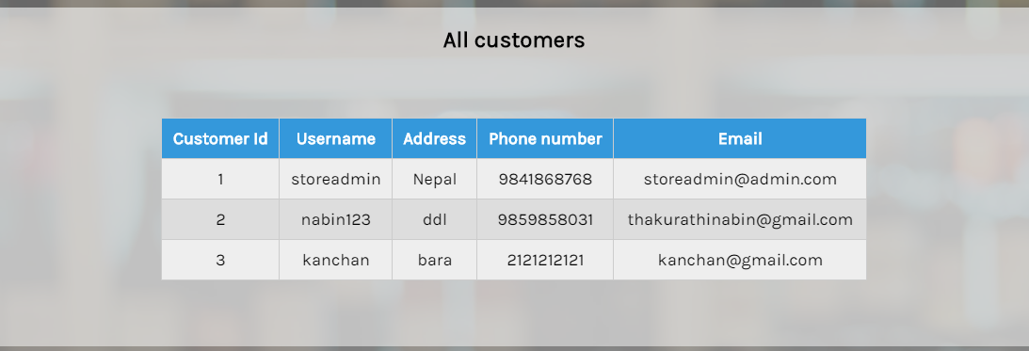

Fig 20: customer details displayed by admin.

1. **Test Name : order viewed by admin**

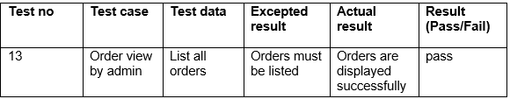

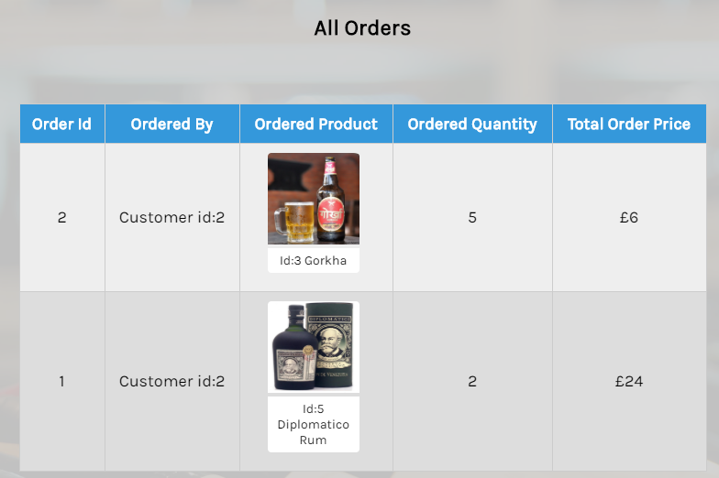

Fig 21: order details.

1. **Test Name : testing invalid password.**

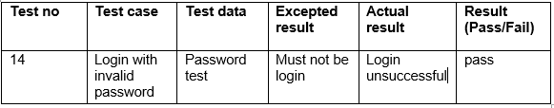

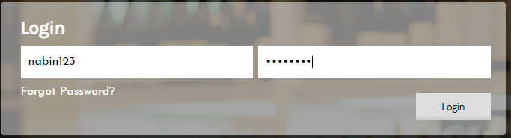

Fig 22: Entering invalid password

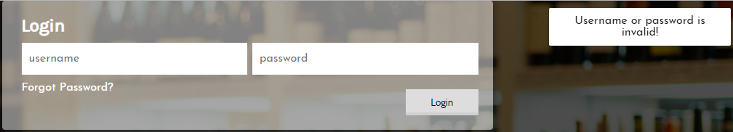

Fig 23: password is invalid.

1. **Test Name : registration with incomplete details.**

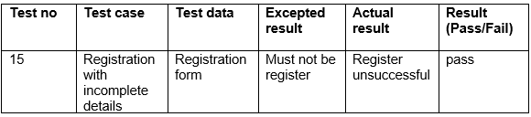

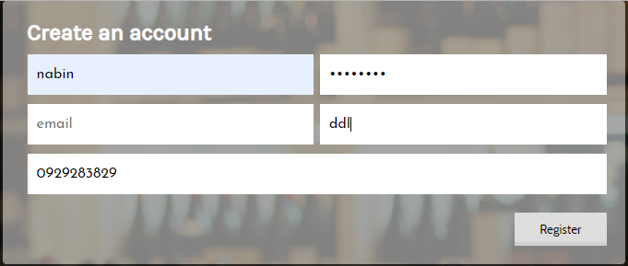

Fig 24: entering details to register.

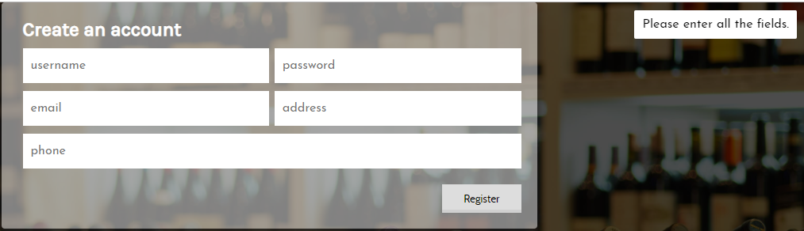

Fig 25: registration unsuccessful.

1. **Unit testing**

Unit testing is known as the type of software testing in which particular units or components are tested. Unit testing is done during the implementation of coding in the system.

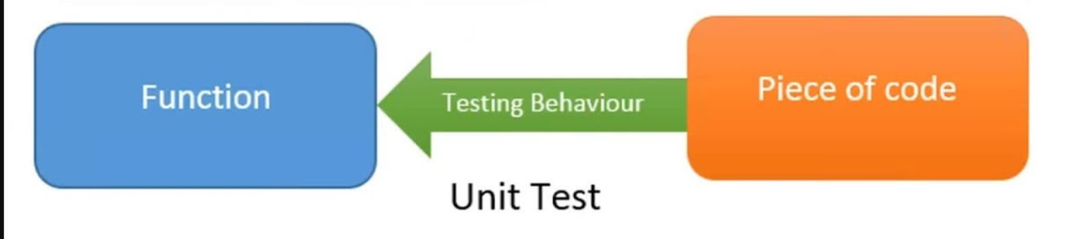

Fig: unit testing.

1. **Test Name : login test**

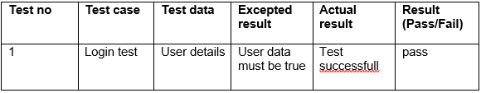

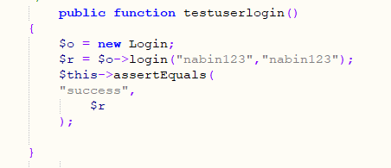

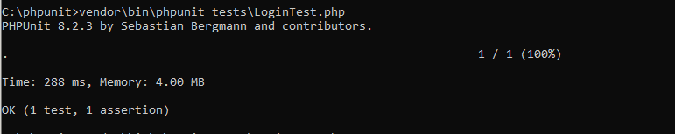

Fig: login test

1. **Test Name : registration test**

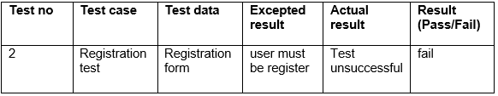

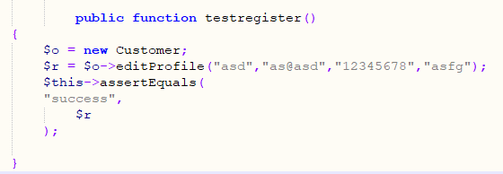

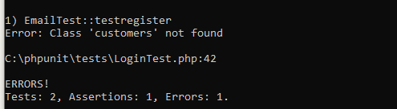

Fig: registration test

1. **Test Name : registration test**

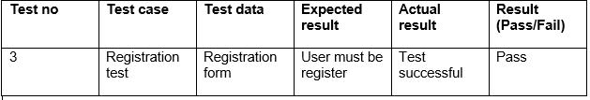



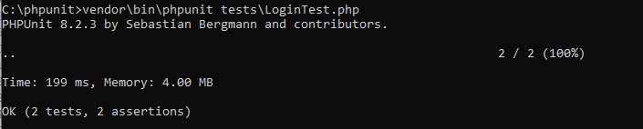

Fig: registration pass result

1. **Test Name : forget password test**

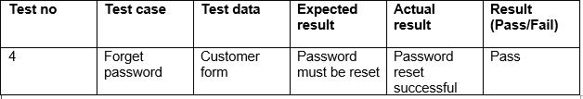

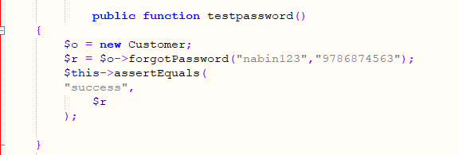

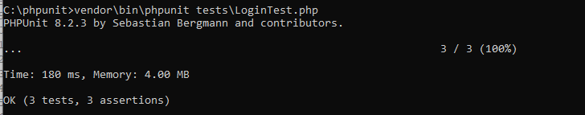

Fig: forget password test